CXI Attendance Tracking System: Automated Emails & Automated Note in Google Sheets

Table of Contents
Introduction 1
The Problem 2
General Objectives 3
Specific Objectives 4
Significance of the System 5
Scope and Limitation 6
High-Level System Flow Chart 7

Introduction
Accurate attendance tracking is a critical administrative function within CXI, as it directly determines the compensation for all agents and management personnel. Recognizing the importance of this process, our Service Level Technicians (SLT) have historically managed it manually. This involves using Google Sheets to meticulously record absences and tardiness, followed by the manual creation and sending of email notifications based on templates.

To enhance efficiency, accuracy, and scalability, we are presenting The CXI Attendance Tracking System: Automated Emails & Automated Note in Google Sheets a web-based system—designed to streamline this process with automated note in Google Sheets and email notifications, freeing up valuable SLT resources.

The Problem
The current manual attendance tracking System is plagued by several significant problems:

1. Inefficiency and Time Consumption: Tracking manually and sending email notification consume a lot of time.
2. Not a beginner friendly: It will take time to understand how to track and send out email notification without having an error.
3. Delayed and Missed out tracked: It is easy to missed out any tracked since there is no counter to determine of how many are still pending or not.

General Objective
The CXI Attendance Tracking System: Automated Emails & Automated Note in Google Sheets ensure accurate and efficient recording of attendance, complemented by automated note in Google Sheets and email notifications.

Specific Objectives
1. To lessen Inefficiency and Time Consumption to a degree of just a click of a button.
2. To make it more user friendly so that every SLT or new hire SLT can easily adapt in attendance tracking.
3. To make the tracking accurate and ensure nothing is missed.

Significance of the System
This system will be beneficial to the following:
- Service Level Technicians (SLT): Will save time, reduce administrative burden, have accurate data, and generate reports instantly.
- HR Payroll: Will have accurate data, more transparent, and fairer attendance data.

Scope and Limitations
Scope:
- The system will be a web-based application.
- It will send email notifications for marked absences and tardiness via a third-party Email API (Gmail API).
- The system will generate raw data that can be access through google sheets.
- The generated raw data that can be access through google sheets will have automated notes that will be posted on sched file.

Limitations:
- The system is solely dependent on the attendance report and advise from the Viber.
- The email notifications accurateness is dependent on the accurate track.
- The system requires a stable internet connection for the web app and email notifications features to function.
- Manual edits made directly in Google Sheets depend on the system.

High-Level System Flow Chart

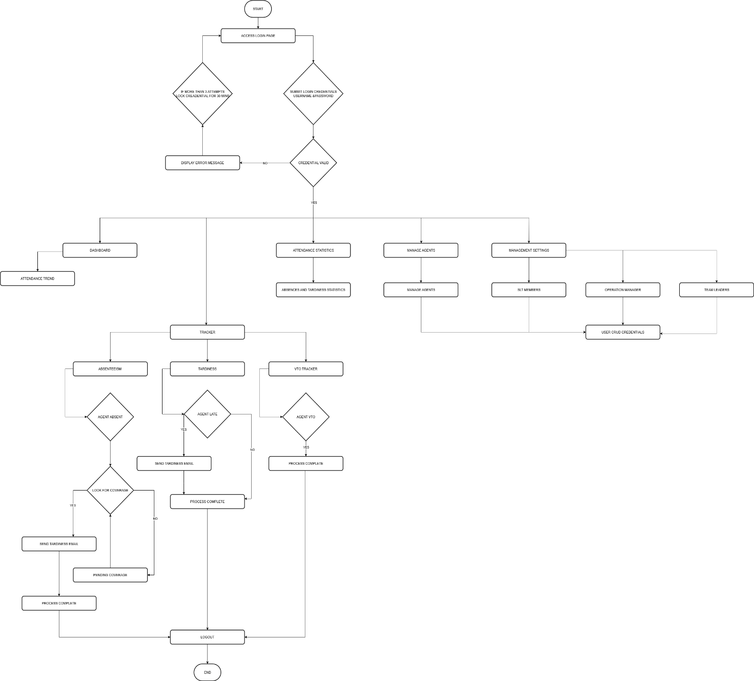
Figure 1.1 Flow Chart

